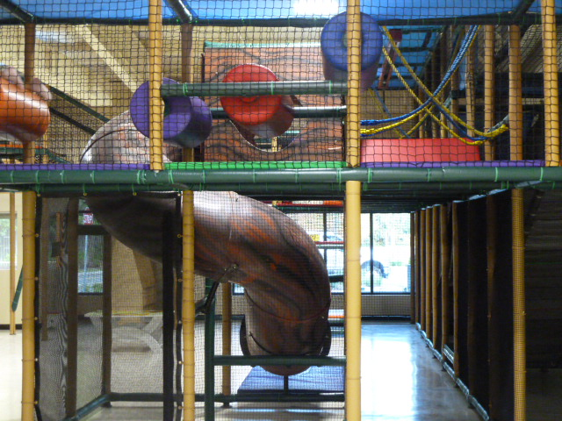
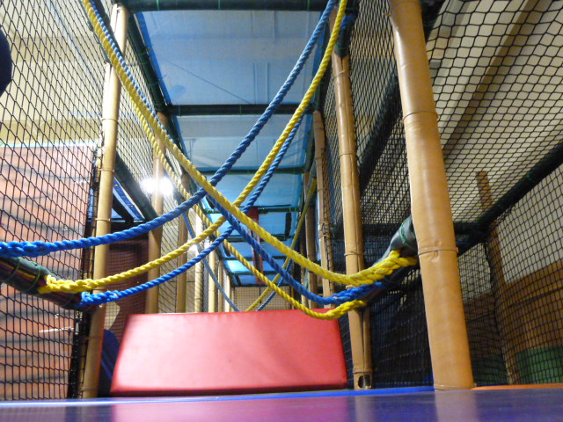
Ed-Venture Land
659 Route 46 West
Kenvil, NJ 07847
973-598-1515

…Your Party Ed-Venture starts here!

Ed-Venture Land is the newest birthday party experience in the Kenvil section of Roxbury. It is conveniently located in Roxbury Township and surrounded by Budd Lake, Mt. Olive, Succasunna, Mt. Arlington, Randolph, Mine Hill and Wharton. Ed-Venture Land is a spectacular indoor play area, complete with colorful, elevated catwalks and slides.

Basic Party
2 hour party with 1 ½ hours in the Ed-Venture Land and a ½ hour in the café area. Host provides food and refreshments. Host is permitted in a ½ hour prior to the start of the party to decorate/set up. Any additional time required may be subject to additional charges.

Premium Party
2 hour party with 1 ½ hours in the Ed-Venture Land and a ½ hour in the café area. Ed-Venture Land supplies the food, refreshments and paper goods while the host provides the cake.

Weekday (Monday to Friday til 4:00PM)
Kids | Basic | Premium
25 | 299.00 | 375.00
15 | 239.00 | 315.00
10 | 199.00 | 275.00

Weekends
Kids | Basic | Premium
25 | 399.00 | 475.00
15 | 309.00 | 385.00
10 | 239.00 | 315.00

Pizza for adults available at an extra cost when requested. Special additions to party available upon request. Socks are to be worn at all times.

